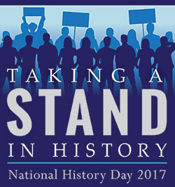
November 9, 2016

Dear Parent/Guardian:

As a parent/guardian with a student enrolled in Advanced American History, you are surely interested in the learning and progress of your student. Allow me to briefly introduce you to an exciting and unique learning opportunity your student is currently involved in called National History Day.

National History Day is a program where students conduct original historical research and present that research in a competitive format. Working individually or collaboratively in groups up to three, students produce historical documentaries, exhibits, dramatic performances, research papers or websites on topics based on an annual theme. This year’s theme is Taking a Stand in History. Students will be expected to develop research skills, work with secondary and primary sources, and consult libraries, museums, and archives within and outside the Seymour area to develop their projects. The project is a class requirement, but your son or daughter may also choose to enter their projects in a regional competition March 4th at UWGB. Students who perform well at the regional level may have the opportunity to present their research April 22nd at the University of Wisconsin – Madison and could even advance to the national competition in Washington D.C.

This year, over 10,000 students across the state and 600,000 across the nation will engage in National History Day research. The gathering and interpreting of information and critical thinking associated with the research process will benefit your student for a lifetime. It will also require considerable work and time management skills to bring a successful project to fruition. I strongly urge you to become actively engaged in the process. Talk with your student about topics, research, new things they are discovering, etc. Encourage him/her to dedicate time outside class to work on NHD research. I would also encourage you to consult www.nhd.org or www.wisconsinhistory.org for more information on the program. As always, feel free to contact me by e-mail at dbrice@seymour.k12.wi.us or by phone at 833-2306 x.477 for more information as well.

Your partnership in furthering the skills and knowledge of our students is greatly appreciated!

Sincerely,

Daniel P. Brice
Social Studies Department
Seymour Community High School

